Name : Shravanthi Logishetti

**Introduction:**

My goal for this article is to test if there is any impact on the fast food chain companies after releasing the drug Wegovy Ozempic in June 2021. I have collected the dataset for one of the food chain companies that is Dominos. Below is the graph showing the sales for the year June 2019 to June 2023. That is the sales before and after the drug release.

If we can see, the sales before July 2021 were highest sales and there is huge decrease in sales after the drug release. Form this we can surely say that there was an impact on this company. But, from the year June 2022 we can see that the sales have started to increase but not much.

Why there is an increase in sales? Will this continue to Increase? I will discuss in these questions in this article.

Increase in sales after drug was introduced:

There was a decreasing trend in the sales just after drug was introduced. By the end of 2022 and beginning of 2023 we can see that there is a slight increase in sales. This is because food companies have often invest in effective marketing and branding strategies to promote their products. These efforts can create strong consumer loyalty and drive sales, even in the presence of other health-related considerations.

2)The accessibility and availability of food play a significant role in consumer choices. Food companies that make their products easily accessible and available may continue to see sales growth.

3)The weight loss drugs contribute to a broader trend of health-conscious choices and as there is a significant shift in consumer demand for healthier food options due to the availability of weight loss drugs some fast-food chains responded by introducing healthier menu options to meet this demand. This involves adding more salads, grilled options, or items with lower calorie and fat content.

These could be the factors why there was a slight increase in sales. But, I wanted to see if this trend continues.

I have forecasted the sales of this company for one year to check if this increasing trend could continue in the future or not.

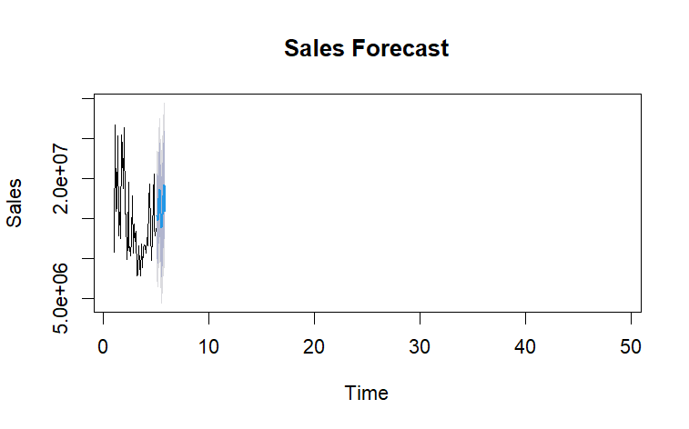

We can see that there is a decline in sales. This decrease in sales is contributed by many factors not just the introduction of weight loss drugs alone.

**Other Reasons:** It is also important to consider other factors that are leading to the decrease in sales of these food chain companies apart from the impact of weight loss drugs.

Many people are becoming aware of the nutritional values of the food. Below is the chart comparing the nutritional values of the items in these food chain companies.

If we can see the average cholesterol level and sugar level is very much higher compared to protein and fibres. More than 240mg/dl is considered high cholesterol and high chances of obesity and diabetics.

1)Competition from Healthier Alternatives:

The rise of healthier fast-casual dining options, salad bars, and restaurants with a focus on fresh ingredients can divert customers away from traditional fast-food chains.

2) Negative Publicity or Scandals:

Negative publicity, food safety issues, or scandals related to a fast-food chain can significantly impact consumer trust and lead to a decline in sales.

3) Economic Downturn:

During economic downturns, consumers may cut back on discretionary spending, including dining out. Fast-food chains, particularly those positioned as affordable options, may experience reduced sales during economic challenges.

And other factors which can lead to the decrease in sales in the future.

Ozempic Sales:

As I have already mentioned that weight loss drug alone is not the factor in decreasing sales. This is because if we see the sales of Ozempic drug we see a downward trend.

Why there is a decreasing trend in the sales of Ozempic:

1)Pricing and Insurance Coverage:

The price of Ozempic is around $900 per month with insurance and $25 with insurance. Moreover, insurance doesn’t cover if it is prescribed just for weight loss alone. So, people have to pay $900 for Ozempic if they are using for weight loss, which is not possible for many people, and they look for other alternatives for weight loss like diet and exercise.

2) Adverse Events or Safety Concerns:

The most common Ozempic side effects are nausea, vomiting, diarrhoea, abdominal pain, and constipation. Serious Ozempic side effects include allergic reactions, changes in vision and pancreatitis. Ozempic has an FDA boxed warning for the risk of thyroid C-cell tumours.

There are many other factors which results in decline in sales of Ozempic.

Conclusion:

We see that there is a decline in sales, and it seems that it will decline even more in future. Being said that this is not only because of the impact of weight loss drugs as we can see that the Ozempic sales have also decreased. There was a slight increase in sales in 2022 because of marketing strategy but that won’t be enough to see a continuous increasing trend in sales. People are focusing more on healthier food options, so if Dominos and other food chains could add more healthier options on the menu or a diet menu options for the Ozempic patients, it could attract more customers and there by can increase sales.

My takeaways from this exercise:

I now know how to collect data and clean and then use the data for analysis. For this project I have collected the sales data from yahoo finance and obesity dataset from kaggles. I have used semi supervised analysis to predict the sales and obesity. I have also forecasted the sales dataset to analyse better. I have used regression analysis for Ozempic sales analysis. This is how I could conclude that Ozempic had very less impact on the food chains as the sales of Ozempic itself is declining.

References:

I have collected data from: 1) <https://finance.yahoo.com/quote/DPZ?p=DPZ&.tsrc=fin-srch>

<https://www.kaggle.com/search?q=obesity+dataset>

<https://www.kaggle.com/weightlosspills221>